|  |  |
| --- | --- |
| Name | Le Thanh Phuong Nam |
| Student number | 23083609 |
| Project title | Mobile Application for Food Recommendation Based on User's Mood Using AI Models |

# DESCRIPTION

Deliverables include:

* A mobile application with a user-friendly interface.
* AI-driven recommendation engine.
* Integration of nutritional dataset and mood assessment tools.

The goal of this Mobile Application for Food Recommendation is to recommend food based on a user’s emotional state instantly. The AI I use in this project combined with psychological insights helps users make better food selection decisions. The app was created with the hope of contributing to support users who care about their personal health and mood-appropriate taste.

# RESEARCH AND BACKGROUND

The project was inspired by the growing awareness of how mood influences food preferences and choices through the research paper that emotional states make a huge difference relating to what people eat: comfort foods like rice Krispies when stressed and health-conscious foods like fresh veggies when happy (Gardner et al., 2014). Leveraging this understanding, this app wants to bridge the gap between mood and optimal food recommendations.

The project relied on artificial Intelligence. The Random Forest algorithm was found a suitable method for studying the relationship between mood and food preference(Chen & Ishwaran, 2012). Random Forests enable robust prediction of dietary choices whereas logistic regression enables us to interpret how mood variables influence choices in the diet (Athey, Tibshirani and Wager, 2019).

Also included in the project is a mood assessment survey from the MFQ-Mood and Feelings Questionnaire (Ang Old et al., 1995). Since those tools are scientifically proven to measure emotional states, the data they collect is reliable for measuring someone’s mood. With its structured design, it helps simplify user input in the app making it a lot easier to use and these assessments give the AI system the means to process these accurate mood data to give accurate recommendations.

In addition, the information in research supports the possibilities of AI in health informatics applications (Qiu et al., 2023). By applying these models, we show that machine learning can help alleviate challenges in personalized health solutions such as dynamic and context-aware food recommendations.

Overall, the combination of this research-backed approach means that I would have a verified application built around well-tested methods and using innovative AI techniques to achieve impactful results.

# OBJECTIVES

## Project Objectives:

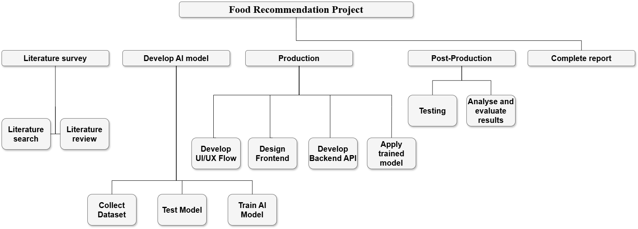

Figure 1. Work Breakdown Structure

* According to the WBS (Figure 1), I will create a user-friendly application to evaluate the mood and suggest food accordingly.
* The goal is to put together a resilient AI model which combines mood assessment with nutritional data.
* Promote healthier eating habits through personalized suggestions.
* Use scientifically validated tools and datasets to ensure reliability and accuracy.

## Research Objectives:

* Explore the psychological connection between mood and food preferences, focusing on studies.
* Investigate the effectiveness of the Random Forest algorithm in mood-based food recommendations.

## Learning Objectives:

* Gain experience in integrating validated assessment tools into technological applications.
* Enhance knowledge of machine learning algorithms, such as Random Forest.
* Understand user experience design principles for creating engaging and effective mobile applications.

# METHODS, TECHNIQUES, TOOLS AND PROCESSES

## Methods:

* Data Collection: Utilize existing datasets like the Food Nutrition Dataset and mood assessment tools.
* Model Development: Implement machine learning algorithms such as Random Forest and explore decentralized learning techniques.
* User Testing: Conduct surveys and usability testing to evaluate application effectiveness.

## Tools:

* Programming: React Native for front-end, Python and Flask for the back-end (Wu and O’Donnell, 2024).
* Databases: SQL for managing user and food data.
* Machine Learning: Random Forest and other predictive models.

**Processes:** Apply Scrum methodology to manage the development schedule.

## User Experience Research and Design

To understand user behavior and validate mood-based food recommendations, I will conduct live surveys or AI model to determine the current mood of users in real time. I will then use the information gathered and personalized preferences to make appropriate recommendations. Based on this, the Figma development will create wireframes and UI designs that mirror easy usability, together with accessibility features, alongside interactions that match the intended mood.

# RISKS AND ISSUES

|  |  |  |
| --- | --- | --- |
| Risk | Mitigation | Contingency |
| Inaccurate mood detection | Use validated tools like the MFQ survey or integrate an AI model of facial emotion images | Integrate multiple mood assessment methods. |
| Data privacy concerns | Employ secure data storage techniques | Anonymize user data for additional security. |
| Model inaccuracies | Test with diverse datasets | Regular model updates with new data. |
| Limited user engagement | Conduct user-centered design workshops | Optimize app interface and engagement features. |
| Algorithm limitations | Use hybrid models combining Logistic Regression and Random Forest (LaValley, 2008) | Explore alternative algorithms such as SVM or Neural Networks. |
| Integration challenges | Conduct iterative testing and modular integration | Maintain flexibility for tool and framework updates. |

Table 1. Risk Management

I define some risks, the causes leading to those risks (Table 1) that I may encounter in the current scope, and how to solve them during the implementation and execution of the upcoming project.

# SPECIALIST RESOURCES AND SUPPORT REQUIRED

1. Access to validated mood assessment tools.

2. Nutritional data from reliable databases from Kaggle.

3. AI development resources, including cloud computing services for model training.

4. Research papers in psychology and nutrition for refining recommendations.

# SOURCES AND REFERENCES

Ang Old, A., Co Ste Llo, E.J., Messer, S.C., Pickles, A., CES Wl, F. and Silver, D., 1995. *DEVELOPMENT OF A SHORT QUESTIONNAIRE FOR USE IN EPIDEMIOLOGICAL STUDIES OF DEPRESSION IN CHILDREN AND ADOLESCENTS*.

Athey, S., Tibshirani, J. and Wager, S., 2019. Generalized random forests. *The Annals of Statistics*, 47(2). <https://doi.org/10.1214/18-AOS1709>.

Gardner, M.P., Wansink, B., Kim, J. and Park, S., 2014. Better moods for better eating?: How mood influences food choice. *Journal of Consumer Psychology*, 24(3), pp.320–335. <https://doi.org/10.1016/j.jcps.2014.01.002>.

Qiu, J., Li, L., Sun, J., Peng, J., Shi, P., Zhang, R., Dong, Y., Lam, K., Lo, F.P.-W., Xiao, B., Yuan, W., Wang, N., Xu, D. and Lo, B., 2023. Large AI Models in Health Informatics: Applications, Challenges, and the Future. *IEEE Journal of Biomedical and Health Informatics*, 27(12), pp.6074–6087. <https://doi.org/10.1109/JBHI.2023.3316750>.

Wu, L. and O’Donnell, C., 2024. Dirt With Flask: Image Processing for Soil Color. In: *SoutheastCon 2024*. IEEE. pp.1–7. <https://doi.org/10.1109/SoutheastCon52093.2024.10500187>.

Chen, X., & Ishwaran, H. (2012). Random forests for genomic data analysis. *Genomics*, *99*(6), 323–329. <https://doi.org/10.1016/j.ygeno.2012.04.003>

LaValley, M. P. (2008). Logistic Regression. *Circulation*, *117*(18), 2395–2399. <https://doi.org/10.1161/CIRCULATIONAHA.106.682658>

# Monthly Project Plan:

|  |  |  |  |  |
| --- | --- | --- | --- | --- |
| **Month** | **Task Name** | **Start** | **End** | **Duration (days)** |
| **January** | **Stage 1: Research & Preparation** | 1/12/2025 | 1/20/2025 | 9 |
| Gather documents on AI/ML and Classification algorithms | 1/12/2025 | 1/13/2025 | 2 |
| Data Collection | 1/14/2025 | 1/17/2025 | 4 |
| Design the survey | 1/18/2025 | 1/19/2025 | 2 |
| Write and submit project proposal | 1/19/2025 | 1/20/2025 | 2 |
| **Stage 2: Data Processing and AI Model Development** | 1/21/2025 | 2/22/2025 | 34 |
| Clean and preprocess data | 1/21/2025 | 1/24/2025 | 4 |
| Define a MoSCow method | 1/21/2025 | 1/24/2025 | 4 |
| Select model algorithms | 1/25/2025 | 1/27/2025 | 3 |
| Train AI model (first version) | 1/28/2025 | 2/4/2025 | 8 |
| **February** | Improve model and evaluate performance (final version) | 2/5/2025 | 2/19/2025 | 15 |
| Write Research report | 2/20/2025 | 2/22/2025 | 3 |
| **Stage 3: Application development** | 2/23/2025 | 3/25/2025 | 31 |
| Deploy model into Flask | 2/23/2025 | 2/26/2025 | 4 |
| Create first sketches and Figma Design | 2/27/2025 | 2/28/2025 | 2 |
| **March** | Develop basic interface on React Native | 3/1/2025 | 3/7/2025 | 7 |
| Connect Flask backend with React Native via API | 3/8/2025 | 3/13/2025 | 6 |
| Integrate AI model into React Native application | 3/14/2025 | 3/20/2025 | 7 |
| Test Application | 3/21/2025 | 3/25/2025 | 5 |
| **Stage 4: Finalize the project** | 3/26/2025 | 5/2/2025 | 38 |
| Draft final proposal | 3/26/2025 | 4/13/2025 | 19 |
| **April** | Write Experiment | 4/14/2025 | 4/19/2025 | 20 |
| User Requirement | 4/20/2025 | 4/22/2025 | 3 |
| Submit Proposal Report | 4/23/2025 | 4/23/2025 | 1 |
| Complete final report | 4/24/2025 | 4/26/2025 | 3 |
| Conduct final testing to ensure no errors remain | 4/27/2025 | 4/29/2025 | 3 |
| Prepare demo and presentation | 4/30/2025 | 5/1/2025 | 2 |
| **May** | Submit Research (Progress) + Final Report + Final Product | 5/2/2025 | 5/2/2025 | 1 |

Table 2. Monthly Project Timeline

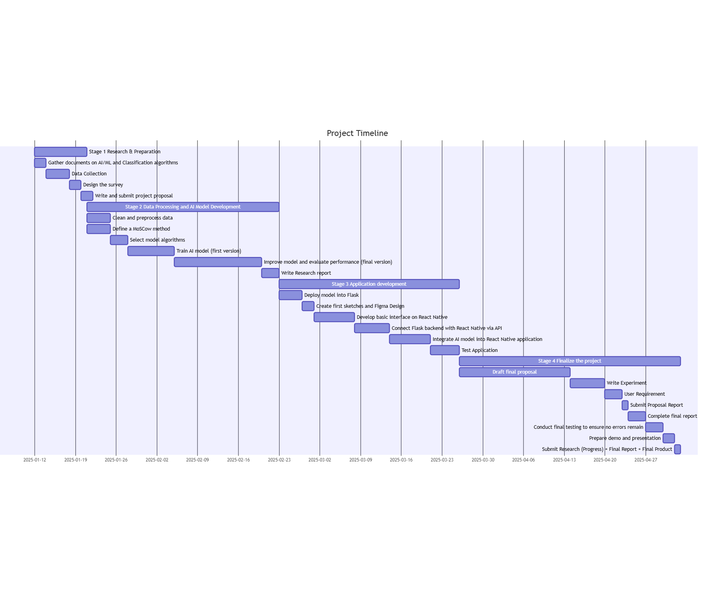

Figure 2. Gantt Chart Schedule



Faculty of Environment & Technology

Faculty Research Ethics Committee (FREC)

**Ethical Review Checklist for Undergraduate and Postgraduate Modules**

*Please provide project details and complete the checklist below.*

**Project Details:**

|  |  |
| --- | --- |
| **Module name** | **Information Technology Project** |
| **Module code** | **UFCFFC-30-3** |
| **Module leader** |  |
| **Project Supervisor** | **Dr. Vi Chi Thanh** |
| **Proposed project title** | Mobile Application for Food Recommendation Based on User's Mood Using AI Models |

**Applicant Details:**

|  |  |
| --- | --- |
| **Name of Student** | Le Thanh Phuong Nam |
| **Student Number** | 23083609 |
| **Student’s email address** | Thanh10.Le@live.uwe.ac.uk |

| **CHECKLIST QUESTIONS** | | **Yes/No** | **Explanation** |
| --- | --- | --- | --- |
|  | Does the proposed project involve **human tissue,** **human participants, animals, environmental damage, or the NHS.** | Yes | *I took a publicly available dataset about tracking daily food intake and nutritional values ​​of each individual, thus, I did not collect data.* |
|  | Will participants be clearly asked to give consent to take part in the research and informed about how data collected in the research will be used? | No |  |
|  | If they choose, can a participant withdraw at any time (prior to a point of “no return” in the use of their data)? Are they told this? | No |  |
|  | Are measures in place to provide confidentiality for participants and ensure secure management and disposal of data collected from them? | No |  |
|  | Does the study involve people who are particularly vulnerable or unable to give informed consent (eg, children or people with learning difficulties)? |  |  |
|  | Could your research cause stress, physical or psychological harm to humans or animals, or environmental damage? |  |  |
|  | Could any aspects of the research lead to unethical behaviour by participants or researchers (eg, invasion of privacy, deceit, coercion, fraud, abuse)? |  |  |
|  | Does the research involve the NHS or collection or storage of human tissue (includes anything containing human cells, such as saliva and urine)? |  |  |

Your explanations should indicate briefly for Qs 2-4 how these requirements will be met, and for Qs 5-8 what the pertinent concerns are.

* **Minimal Risk:** If **Q 1 is answered ‘No’**, then no ethics approval is needed.
* **Low Risk:** If **Qs 2-4 are answered ‘Yes’ and** **Qs 5-8 are answered ‘No’**, then no approval is needed from the *Faculty Research Ethics Committee* (FREC). However, your supervisor must approve (a) your information and consent forms (Qs 2 & 3) and (b) your measures for participant confidentiality and secure data management (Q4).
* **High Risk:** If **any of Qs 5-8 are answered ‘Yes’**, then you must submit an application for full ethics approval *before* the project can start.This can take up to 6 weeks. Consult your supervisor about how to apply for full ethics approval.

**Risk Assessment:** Separate guidance on risk assessment can be found on UWE’s Health and Safety forms webpage at <https://go.uwe.ac.uk/RiskAssessment>. If needed, you must complete a Risk Assessment form. This must also be attached to your application for full ethics approval if your project is **High Risk**.

|  |
| --- |
| **Your supervisor must check your responses above *before* you submit this form.** |
| **Submit this completed form via the *Assignments* area in Blackboard (or elsewhere if so directed by the module leader or your supervisor)***.* |
| After you have uploaded this form, your supervisor will confirm it has been correctly completed by “marking” it as *Passed*/100% via the *My Grades* link on the Blackboard*.* |

Further research ethics guidance is available at <http://www1.uwe.ac.uk/research/researchethics>